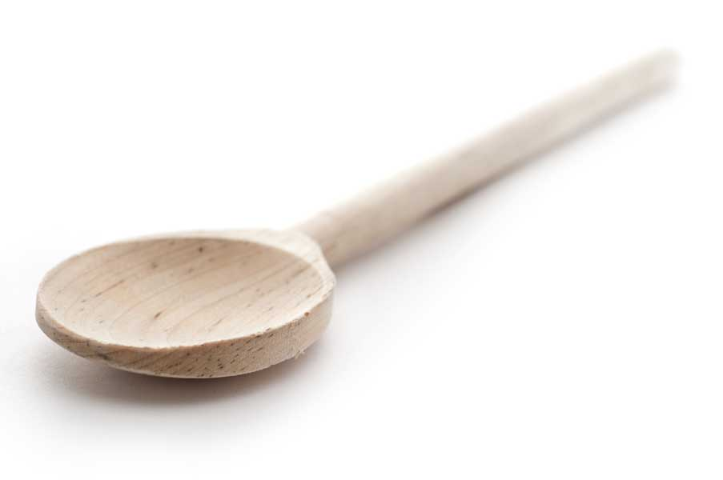
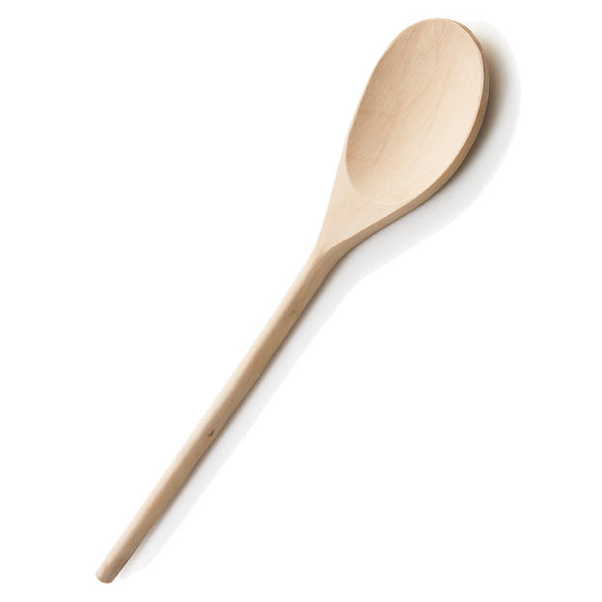
favs
frans

Margarita

Ingredients

2 cups crushed ice
1 12-oz. can frozen Limeade
1 12-oz. can Corona beer (or your favorite beer, but I prefer Corona)
6 oz. tequila
6 oz. triple sec

Lime for rim of glass
Coarse salt

Directions

Add 2 cups of crushed ice to large pitcher. Pour Limeade, beer, tequila, and Triple sec (or Cointreau) over the ice and stir the mixture with a long spoon. After thoroughly mixing, place pitcher in freezer. Break up mixture with wooden spoon or fork when ready to serve. To serve, rub the rim of a margarita glass with lime, and dip in coarse salt. Pour Margarita mixture and garnish with a slice of lime if desired.

If you don't have time to freeze first, crush ice cubes in blender. Place ice cubes in prepared glasses and pour Margarita mixture over.

Source: My friend, Donna

www.fransfavs.com

