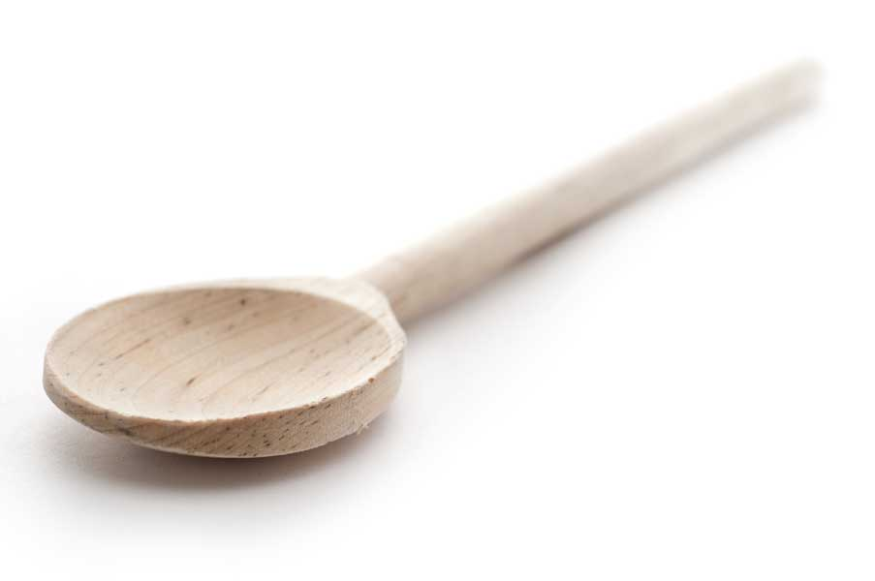

favs
frans

Chicken Roulades with Chorizo Sausage and Manchego Cheese

Ingredients

Stuffing

4 boneless skinless chicken breasts
Extra-virgin olive oil
1 onion, cut into 1/4-inch dice
Kosher salt
Pinch crushed red pepper
1 clove garlic, smashed and finely chopped
1/2 pound Mexican chorizo, casing removed
1/2 cup Panco breadcrumbs
1/2 cup grated aged Manchego cheese (Iberico cheese works great as well)
1/2 bunch fresh Italian parsley, finely chopped
1/4 cup sliced almonds, toasted and roughly chopped
1 egg

Breading

1/2 cup flour
1 egg
1 cup panko breadcrumbs

Sauce

Extra-virgin olive oil
1 shallot, finely chopped
1/4 cup sherry vinegar
14 oz chicken stock
2 tbl. (1/4 stick) unsalted butter

Directions

I used two large plates and two large mixing bowls, and one large fry pan. I always have one cutting board and knife for the meat, and a separate cutting board and knife for some dinner veggies. I group the items separately for the stuffing, breading, and sauce.
Chop one large onion into 1/4 inch dice and sauté in olive oil and a sprinkle of crushed red pepper over medium heat.
During the time that the onions are sautéing, crumble up 1/2 pound of chorizo sausage and put in a holding bowl. Finely chop one clove of garlic. Also during this onion cooking time, trim and butterfly four large chicken breasts. Place each breast flat out on the cutting board, cover with plastic wrap, and pound lightly with the flat side of a meat mallet to flatten and even out the chicken until they are about 1/4 inch thick. Carefully place these on a large plate until the stuffing is ready.
During the chicken prep time, the onions will probably be done and you can add the finely chopped garlic and the crumbled chorizo to the onions and cook for another eight minutes or so, stirring occasionally between flattening the chicken and other preparations (follows).
Chop a bunch of Italian parsley (2/3 cup chopped) and chop 1/4 cup of almonds.
Grate about 1/2 to 2/3 cup of manchego cheese (I used Iberico cheese).
Dump cooked chorizo mix into large mixing bowl. Add Panko bread crumbs, 1 tsp salt, grated cheese, almonds, one beaten egg, and parsley, and mix thoroughly.
Using about 1/4 of the stuffing mix per chicken breast, place an even layer of stuffing across the chicken breast leaving a 1/2 inch border at the edges. Roll the chicken breast being careful not to roll too tightly and squeeze out stuffing. Hold together with toothpicks. Place back onto holding plate.
Breading
Pour 1/2 cup of olive oil in large fry pan and heat to medium high.
Beat one egg and one teaspoon of water, and pour onto a large plate. Pour about 1/2 cup of flour onto another large plate, and pour about 1 cup of Panko bread crumbs onto a third plate.
Coat each roulade in the following order; flour, egg, bread crumbs, then place in the fry pan. Turn the roulades in order to brown on all sides. I did two at a time. Place the browned roulades on a flat baking pan on paper towels to soak up excess olive oil. Set aside.
Preparing the Sauce
Pour out excess oil into waste container and wipe pan. Place about 1 tbsp. of extra virgin olive oil in the pan and heat to medium.
Chop shallot into fine pieces and sauté in pan. When shallots are sautéed, add 1/4 cup of sherry vinegar, bring to boil, and reduce by 50%.
Add 7 oz. of chicken broth to the sauce and reduce by 50%.
At this time, preheat oven to 350 degrees F.
Add the remaining 7 oz of chicken stock and boil to again reduce by 50%.
During the broth reductions, it is a good time to prepare some vegetables.
During this final reduction of the sauce, you can place the roulades on the middle shelf of the oven to bake and set the timer for 10 minutes.
If the force is with you, everything will magically finish about the same time.
At the end of the reduction, add two pats of butter to the sauce and stir in.
When finished, let roulades cool for about 1-2 minutes after removing from the oven, and then slice into four or five pieces.
Plate the vegetables and line the roulades along one edge of the veggies. Top with the sauce and serve. Serves 4 to 6.
http://www.fransfavs.com

