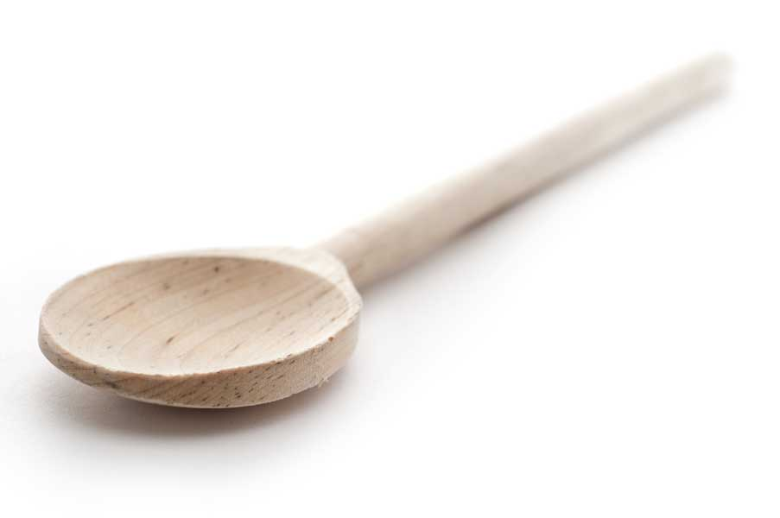

favs
frans

Green Basmati Rice

Preparation time: 5 minutes
Cooking time: 20 minutes
Yield: 6 servings

Ingredients

2 to 3 tbl. vegetable oil
1 tbl. minced garlic
1 large yellow onion, chopped
2 cups uncooked basmati rice (jasmine rice can be substituted)
2 cans (14½ ounces each) chicken broth
5 oz. coconut milk (cream of coconut works fine)
Freshly ground pepper
2/3 cup each: fresh cilantro leaves, thinly sliced green onions

Directions

Heat oil in 2-quart pot over medium-high heat. Add onion; cook, stirring often, until softened, about 6 minutes. Add garlic and cook for a minute or two more, stirring frequently. Stir in rice; cook, stirring often, 1 minute.

Add broth, coconut milk, and pepper. Heat to boiling; cover. Reduce heat to simmer; cook until rice is just tender, about 17 minutes. Toss in cilantro leaves and green onions; serve hot.

Fran’s notes: The original recipe called for low-sodium chicken broth and a 1/2 tsp. of salt. I rarely use low-sodium chicken broth, preferring to use the full strength salted broth; and then I eliminate the added salt.

www.fransfavs.com

