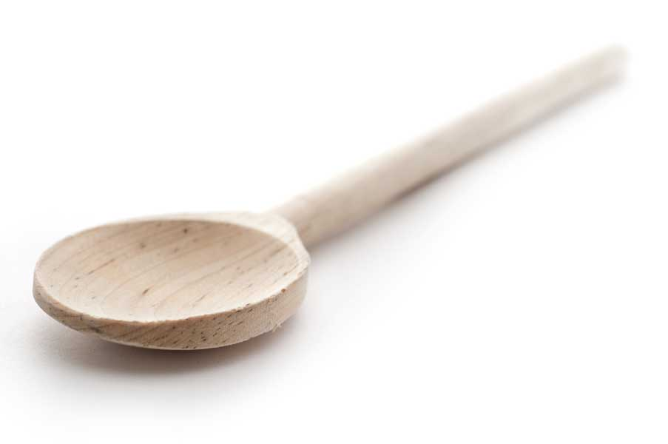
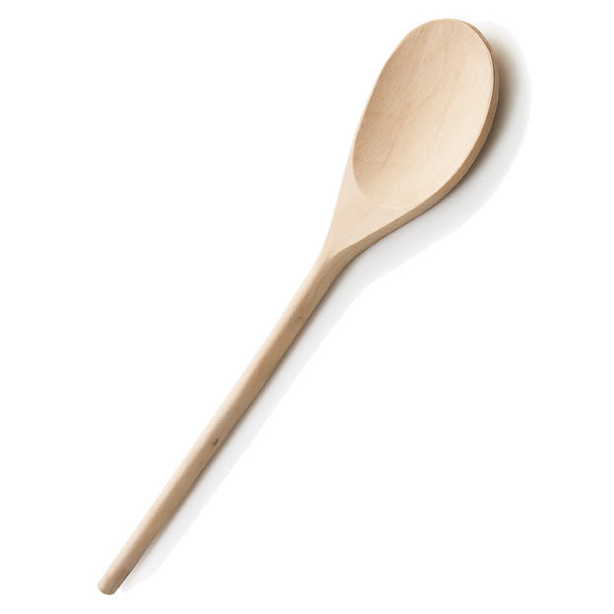
favs
frans

Perfectly Peppermint Brownies

Ingredients for Brownies

8 oz. unsweetened chocolate
1 1/2 cups unsalted butter (3 sticks)
3 cups sugar
6 large eggs, lightly beaten
1/2 tsp. peppermint extract
2 tsp. vanilla extract
1/2 tsp. salt
2 cups flour

Ingredients for Mint Ganache

1/2 cup heavy cream
10 oz. fine-quality white chocolate, chopped
2 tbl. peppermint schnapps
1 tsp. peppermint extract

Ingredients for Chocolate Ganache

1 cup heavy cream
10 oz. fine-quality bittersweet chocolate (not unsweetened), finely chopped

Topping: 1 cup Andes Peppermint Crunch Baking Chips

Directions for Brownies

Preheat the oven to 350° F. Line a 9×13-inch baking pan with overhanging foil and spray lightly with cooking spray.

Use a large microwavable mixing bowl to microwave chocolate according to directions on box, adding butter about halfway through so that it can melt with the chocolate. Add the sugar and eggs to the chocolate mixture in the bowl, whisking until combined. Whisk in the peppermint and vanilla extracts and the salt. Whisk in the flour just until incorporated.

Bake 30-35 minutes. (Do not overbake—mine were done in exactly 30 minutes.)

Transfer to a wire cooling rack and let cool to room temperature.

Directions for Mint Ganache

Microwave the white chocolate according to directions on package. Microwave the cream for about a minute; then pour warm cream over white chocolate and whisk until smooth. Stir in peppermint schnapps and extract and chill, covered, stirring occasionally, until thick, about 1 hour.

Directions for Chocolate Ganache

Microwave the bittersweet chocolate according to directions on package. Microwave the cream for about a minute; then pour warm cream over bittersweet chocolate and whisk until smooth. Chill, covered, stirring occasionally, until thick, about 30 minutes.

Assemble Layers

Spread chilled mint ganache over top of cooled brownie in a thin even layer using offset spatula; then chill until firm but still slightly sticky, about 30 minutes.

Spread chilled chocolate ganache over mint and sprinkle with Andes Peppermint Crunch baking chips. Chill until firm, about 2 hours.

Lift dessert out of pan using foil overhang. Run a heavy knife under hot water and wipe dry; then trim so that brownie edges are straight. Cut dessert into squares and peel from foil. You will need to wipe knife periodically so that you make clean cuts.

Brownies are best served chilled.

www.fransfavs.com

