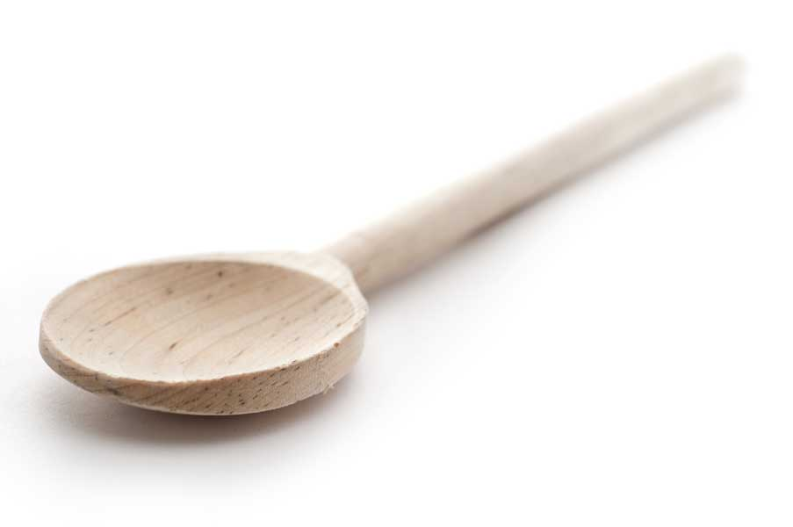
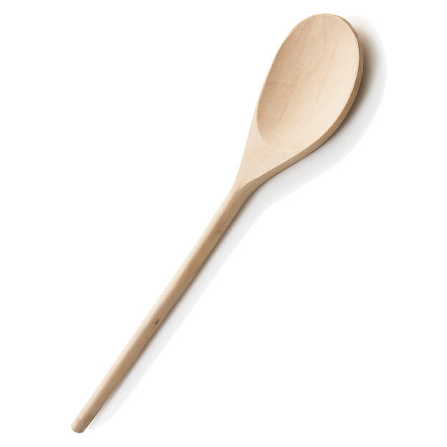
favs
frans

Tiramisu Cookie Balls

Ingredients

1 pkg. (8 oz.) cream cheese, softened
60 Nilla Wafers, finely crushed (about 2 cups)
3 tbl. Maxwell House International Café instant coffee, Café Vienna, divided
2 pkgs. (6 squares each) Baker’s White Chocolate, melted
2 squares Baker’s Semi-Sweet Chocolate, melted

Directions

Mix cream cheese, cookie crumbs and 1 tbl. coffee until well blended.

Shape into 36 (1-inch) balls.

Freeze 10 mins. Mix white chocolate and remaining coffee.

Dip balls in white chocolate mixture. To easily coat balls with the melted chocolate, add balls, in batches, to bowl of melted chocolate. Use 2 forks to roll balls in chocolate until evenly coated. Remove balls with forks, letting excess chocolate drip back into bowl. Place balls in single layer in shallow waxed paper-lined pan; let stand until firm.

Drizzle with semi-sweet chocolate.

Refrigerate 1 hour or until firm. Store in tightly covered container in refrigerator.

Fran’s Notes

If you’re not aware, you should know that chocolate chips are designed to keep their shape when used in cookies and cakes. They are, therefore, not meant to be melted and used for coatings. Despite this caveat, I often melt them when combined with butter and cream for a ganache. Do not attempt to try melting white chocolate chips for this recipe! It will seize up and thicken when you add the coffee. (Ask me how I know!) Stick to the Baker’s white chocolate, and you’ll be fine. I did use semisweet chocolate chips for melting and drizzling over the finished cookie balls as usual quite successfully.

www.fransfavs.com

