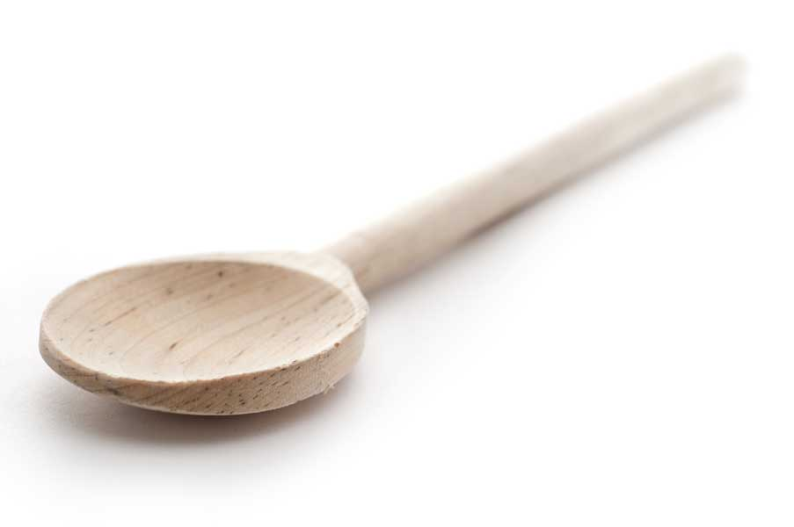
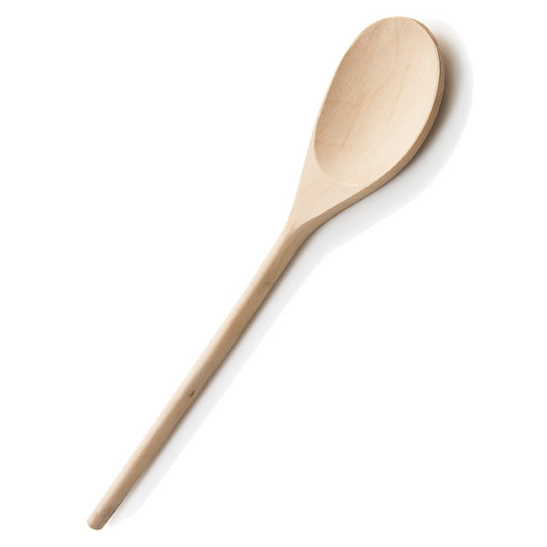
favs
frans

Macadamia Double-Decker Brownie Bars

Ingredients for the brownie layer:

Cooking spray
6 oz. (12 tbl.) unsalted butter, cut into large chunks
1-1/2 cups granulated sugar
2-1/4 oz. (3/4 cup) unsweetened cocoa powder (natural or Dutch processed)
1/4 tsp. table salt
2 large eggs
1 tsp. pure vanilla extract
3-1/2 oz. (3/4 cup) unbleached all-purpose flour

Tip: For the best results, measure your flour by weight instead of volume. (1 cup of all-purpose flour equals 4-1/2 oz.) If you don’t have a scale, be sure to use the proper technique when filling your measuring cups.

Ingredients for the macadamia layer:

1/2 cup firmly packed light brown sugar
1-1/2 oz. (1/3 cup) unbleached all-purpose flour
2/3 cup light corn syrup
1-1/2 oz. (3 Tbs.) unsalted butter, melted
1-1/2 tsp. pure vanilla extract
2 large eggs
1-1/2 cups roughly chopped salted macadamia nuts
1/3 cup sweetened coconut flakes

Directions

Position a rack in the center of the oven and heat the oven to 325ºF. Line the bottom and sides of a 9x13-inch baking pan with foil, leaving some overhang on the sides, and spray with cooking spray.

Make the brownie layer

In a medium saucepan over medium heat, whisk the butter until it is melted. Remove the pan from the heat and add the sugar, cocoa powder, and salt. Whisk until well blended, about 1 minute. Add the eggs and vanilla and whisk until smooth. Add the flour and stir with a rubber spatula until blended. Scrape into the prepared pan and spread evenly. Bake until the top is shiny and dry-looking and the brownie springs back very slightly when pressed with a fingertip, about 20 minutes. (The brownie should not be completely baked.) Remove from the oven and put on a rack.

While the brownie layer is baking, make the macadamia topping:

Tip: Dipping the knife in warm water and wiping it dry between cuts will keep the gooey topping from sticking to the knife.

In a large mixing bowl, combine the brown sugar and flour. Whisk until well blended, breaking up any large clumps. Add the corn syrup, melted butter, and vanilla. Whisk until blended, about 1 minute. Add the eggs and whisk just until combined, about 30 seconds. (Don’t overmix or the batter will be foamy.) Add the nuts and coconut and stir with a rubber spatula until evenly blended.

Pour the macadamia topping over the warm, partially baked brownie layer. Using a spatula, carefully spread the mixture into an even layer. Return the pan to the oven and bake until the top is golden brown, 37 to 40 minutes. Transfer the pan to a rack to cool completely.

Using the foil as handles, lift the rectangle from the pan and invert onto a work surface. Carefully peel away the foil. Flip right side up. Using a sharp knife, cut into 2x2-inch squares and then cut each square into triangles; or, if you prefer, cut them into 1x1-inch squares.

These brownies are best chilled, so keep them refrigerated until time to serve.

Make Ahead Tips

After the brownie and macadamia layers have been baked and cooled, the entire pan can be wrapped in plastic wrap, then foil, and frozen for up to 1 month.

www.fransfavs.com

