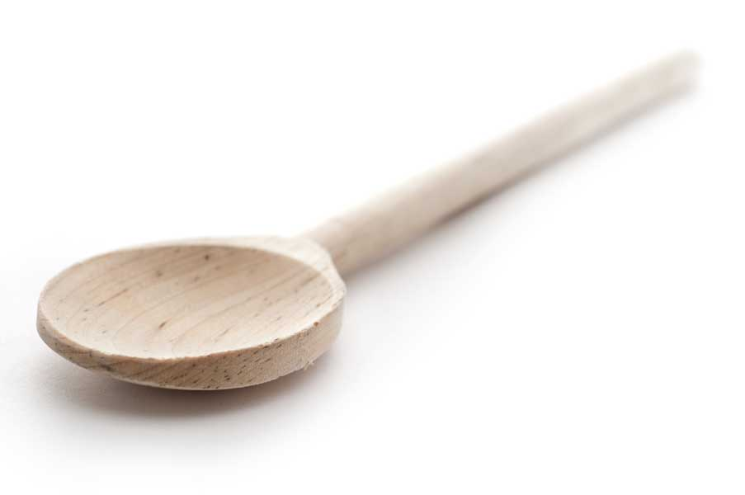
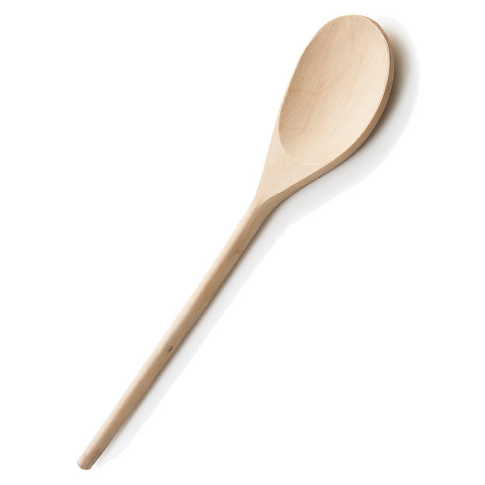
favs
frans

Cornbread Pudding

Ingredients

1 box Jiffy cornbread mix
2 cans creamed corn
2 eggs, beaten
1 stick butter, melted

Directions

Combine and mix all ingredients in a large bowl using a wooden spoon. Do not overmix.

Pour into greased 2-qt. Corning casserole. Bake at 350º for 55 to 60 minutes, until top is golden brown. Testing for doneness is the same as for a custard. Stick a knife in the center. It should come up wet but clear. If you see a lot of gooey batter, it needs more time to bake. You can use a shallower pan, just adjust the baking time.

This reheats in the microwave really well.

www.fransfavs.com

