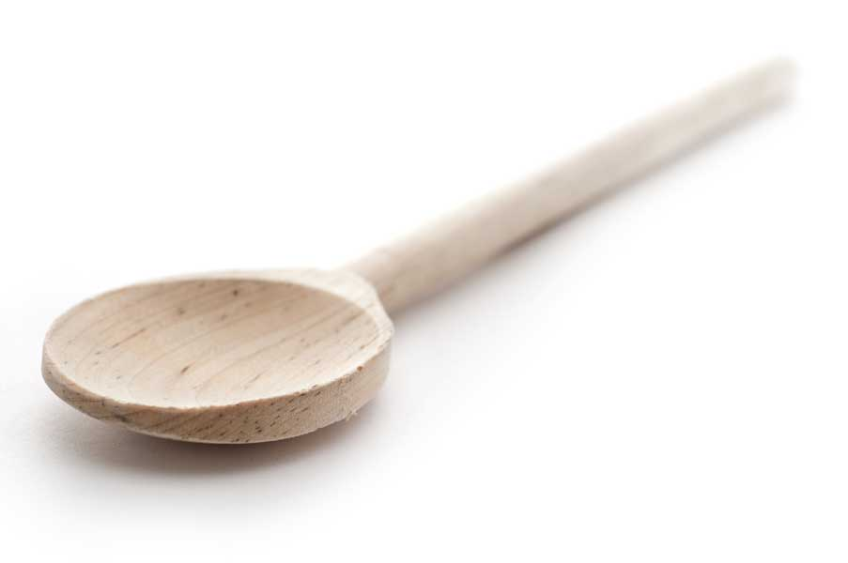
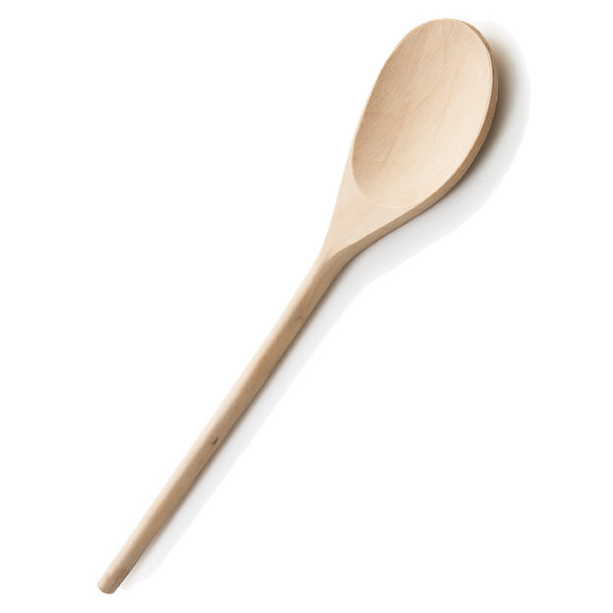
favs
frans

Shrimp Francesca

Ingredients

1 pound uncooked large shrimp, peeled and deveined
1 (8 ounce) can (8- to 10-count) artichoke hearts in water, drained
1/2 cup Italian seasoned bread crumbs
1 tbl. chopped fresh parsley
1 lemon, juiced
1/2 cup butter
1 1/2 tbl. minced garlic
1 tbl. finely shredded imported Romano cheese

Directions

Preheat oven to 375 degrees F. Lightly grease an 8x10-inch baking dish.

Arrange the shrimp in the bottom of the prepared baking dish. Gently squeeze any excess liquid from the artichoke hearts, break the hearts into quarters, and arrange in spaces between the shrimp. Sprinkle the bread crumbs and parsley over the shrimp and artichoke hearts; sprinkle lemon juice over the crumbs.

Melt butter with garlic in a small saucepan over medium-low heat; drizzle the butter mixture over the bread crumbs. Sprinkle the top with Romano cheese.

Bake in the preheated oven until the crumbs and cheese brown lightly and the shrimp turn opaque and orange-pink in color, 10 to 12 minutes. Serve hot.

www.fransfavs.com

