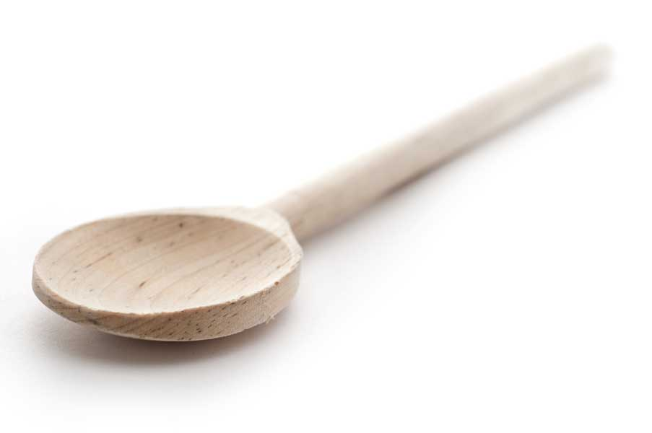
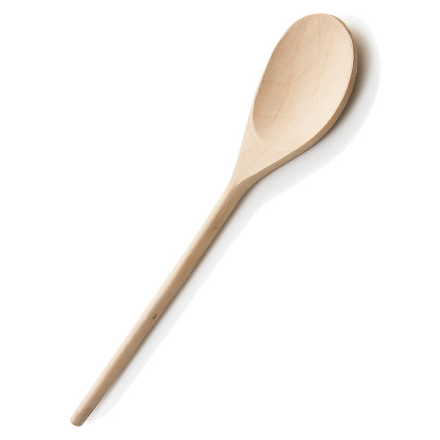
favs
frans

Strawberry Salsa

Ingredients

1 lb. strawberries, hulled and diced
1/4 cup thinly sliced green onions
1 jalapeño, seeded and diced
1/4 cup cilantro, chopped
2 tbl. fresh lime juice
1 tbl. agave syrup or honey (I used agave)
1/8 tsp. salt

Directions

Gently mix ingredients together in a bowl. Serve with tortilla chips or over fish or chicken.

www.fransfavs.com

