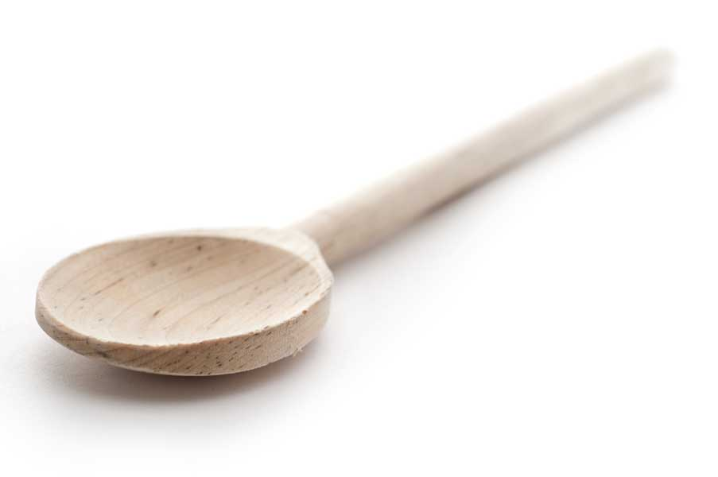
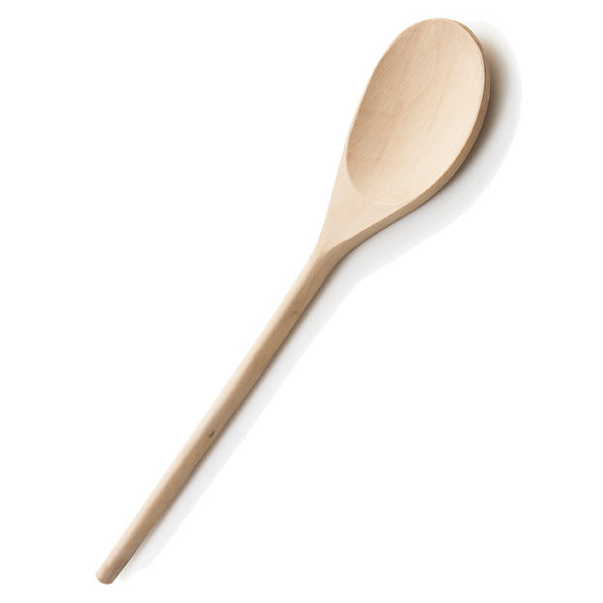
favs
frans

Pumpkin Cupcakes with Cream Cheese Frosting

Ingredients for Cupcakes

4 eggs
3 cups sugar
1 cup canola oil
1 15- or 16-oz. can pumpkin (plain—not pumpkin pie mix)
2/3 cup cold water
2 tsp. baking soda
1 tsp. baking powder
2 tsp. salt
1/2 tsp. cinnamon
1/2 tsp. cloves
1 tsp. allspice
1 tsp. nutmeg
3 1/2 cups flour

Directions for Cupcakes

Use a baking spray which contains flour to spray three 12-cup cupcake tins. If you fill them slightly higher than halfway, you will get 36 cupcakes. If you want larger cupcakes, fill them 2/3 to 3/4 full and you will get 30 cupcakes. Alternatively, you can use paper cupcake liners and you will definitely get 36 cupcakes.

Beat eggs in large mixing bowl until frothy. Add sugar; beat until fluffy. Mix in oil. Add pumpkin; mix well. Add water and mix well. Add dry ingredients and mix well to incorporate. Batter will be fairly thick.

Bake at 350º for approx. 15 mins. Baking time will depend on how many muffin wells you’ve filled and whether you’ve used paper cups to line the wells (will slightly reduce the volume of the batter). Do a toothpick test—it’s OK to see a few tender crumbs clinging to the toothpick. I did not use paper cup liners and made 30 cupcakes which were done to perfection in 15 minutes.

Ingredients for Cream Cheese Frosting

8 oz. cream cheese, softened
6 tbl. butter, softened
1 tbl. freshly grated lemon rind
4 cups confectioners' sugar

Directions for Cream Cheese Frosting

Cream butter and cheese together. Add grated lemon rind and confectioners’ sugar. You can add a little water or milk if necessary to get desired consistency, but it’s really not necessary.

www.fransfavs.com

