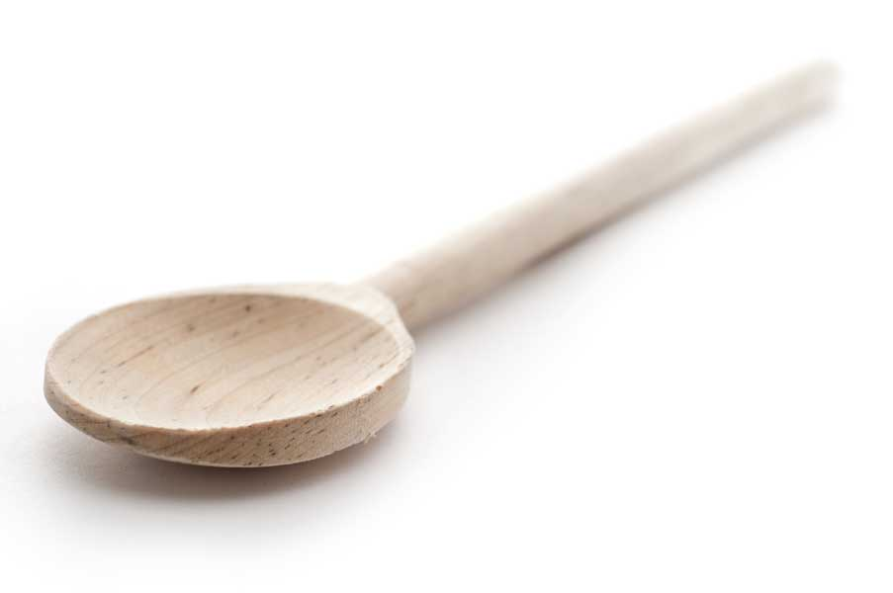
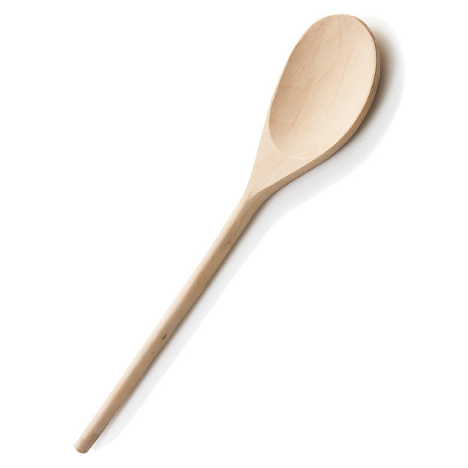
favs
frans

Chinese Stir Fry aka Mom’s & Dad’s Stir Fry

Fran’s Notes

The quantities and types of meat and vegetables are merely suggestions. If you are cooking for more than four people, you will most likely need to cook two batches of both meat and vegetables because, otherwise, the wok will be too full to properly stir fry.

Ingredients

Vegetable oil

Aromatics:

1 to 2 cloves garlic, either minced or crushed
3 to 4 thin slices of ginger root, minced

Meat:

1.5 - 2 lbs. chicken, beef, or pork sliced into thin pieces; 1 to 2" long, approx. 1/2" wide, approx. 1/4" thick

Vegetables:

Broccoli
Any color bell peppers
Onions
Carrots
Pea pods
water chestnuts (canned)
Baby corn (canned)
Bamboo shoots (canned), etc.

All fresh vegetables should be cut into bite-sized pieces that will be easy to stir fry. A general rule is to try to cut your vegetables in the same manner in any dish; e.g. diced or in thin strings.

Flavorings:

Oyster sauce
Sesame seed oil
Chinese rice wine
Soy sauce, optional

VEGETABLE SEASONING – Mix ingredients together to blend

2 tbl. rice wine
1/4 tsp. sugar
1/8 tsp. salt

OYSTER SAUCE – Mix ingredients together to blend

1 1/2 tsp. corn starch
3 tbl. water
6 tbl. oyster sauce
1/2 tsp. sugar
1 1/2 tsp. sesame oil

Put cornstarch in small bowl; then add water slowly, whisking all the while—otherwise it will clump. Add oyster sauce, sugar and sesame oil and whisk to combine.

Special Cooking Equipment

Chinese wok
Long-handled spatula

Directions

Heat your wok on high for a couple of minutes. Add approximately 2 tablespoons of oil to the pan and swirl it around and up the sides of the wok. You should see the oil shimmer.

Add the vegetables of your choice and stir fry for 2 or 3 minutes if you like your veggies tender crisp or a few minutes longer if you prefer your veggies softer. Add the vegetable seasoning when the vegetables are just about to your liking. Stir fry for an additional 30 seconds to mix in the seasoning; then remove the vegetables to a holding bowl.

Add another tablespoon or two of oil, and add the garlic and ginger root. Stir fry for 30 to 60 seconds and immediately add your choice of meat. Keep things moving quickly with your spatula so that the aromatics do not burn. When the meat is no longer pink, drain off any excess liquid released by the meat—if any. Add the vegetables back in and then add the oyster sauce. Stir fry for another minute to combine the meat and vegetables and distribute the oyster sauce.

Serve immediately over rice.

Source: Frantastic original

www.fransfavs.com

