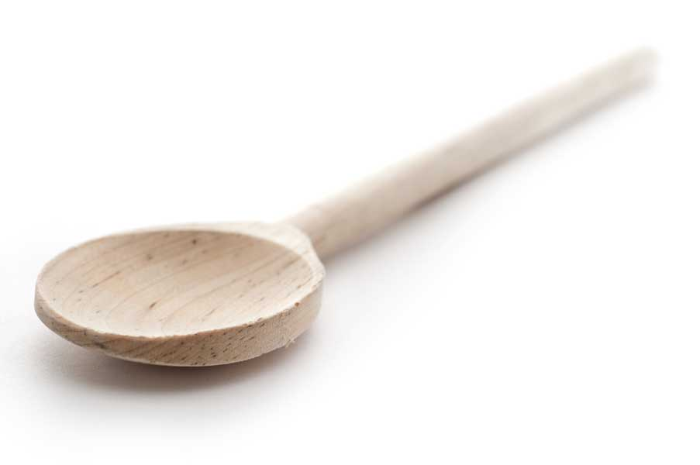
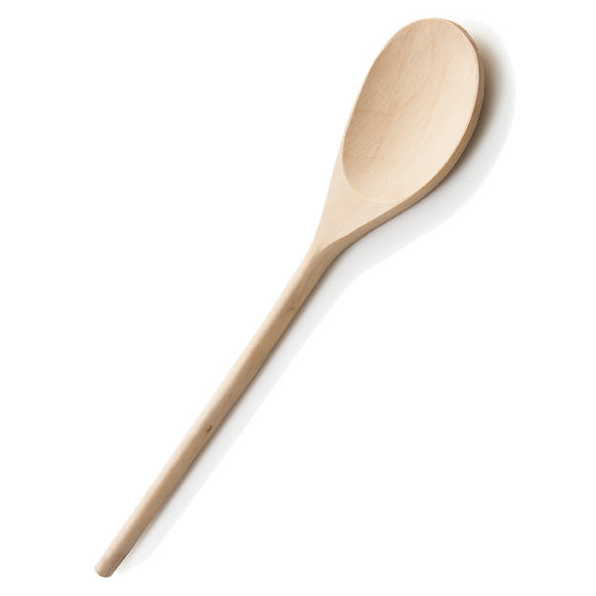
favs
frans

Blueberry-Streusel Bars with Lemon Cream Filling

Ingredients

3 cups flour
1 1/2 cups old-fashioned rolled oats (not quick oats)
1 1/3 cups packed light brown sugar
1 tsp. salt
1 tsp. baking powder
1 cup (2 sticks) unsalted butter, at room temperature
1 large egg, separated
14-oz. can sweetened condensed milk
1/2 cup fresh lemon juice
2 tsp. lemon zest
2 1/2 cups (about 13 oz.) room-temperature blueberries

Directions

Preheat oven to 350 F. Line a 13x9 metal baking pan with foil, leaving a slight overhang on both sides to lift the bars out. Spray the pan/foil with cooking spray.

Whisk the flour, oats, brown sugar, salt and baking powder together in a large bowl. Use a pastry blender (or your fingers) to cut the butter into the dry ingredients completely (in other words, until the pieces of butter aren't visible anymore). Set aside and reserve 2 cups of these crumbs for the topping. Beat the egg white with a fork until broken up and foamy. Add it to the crumbs and mix to incorporate. Transfer the mixture to the prepared pan and press to form an even layer of crust. Bake for about 10-12 minutes, or until the top starts to look dry. The top will have puffed up a little bit.

Meanwhile, whisk the condensed milk, lemon juice, lemon zest, and egg yolk together in a medium bowl. Let stand for 5 minutes; the mixture will begin to thicken slightly.

When the crust has finished baking, transfer the pan to a wire rack and sprinkle the blueberries evenly over the hot crust. Drop spoonsful of the lemon mixture over the blueberries; then spread the lemon mixture gently to distribute it. Work carefully so you don't crush the berries; the lemon layer doesn't have to cover every bit of the crust. Bake until the lemon layer begins to form a shiny skin, about 7-8 minutes.

Remove the pan to a wire rack and sprinkle the reserved crumb mixture over the lemon layer. Use all of the crumb mixture to cover the lemon layer completely. Bake for 25 to 30 minutes, or until the filling is bubbling at the edges and the streusel topping is golden brown.

Transfer the pan to a wire rack and let the bars cool for about an hour, until just warm. Remove them from the pan using the foil overhang and let cool completely on the wire rack. Cut into squares before serving. The bars should be stored in the refrigerator.

www.fransfavs.com

