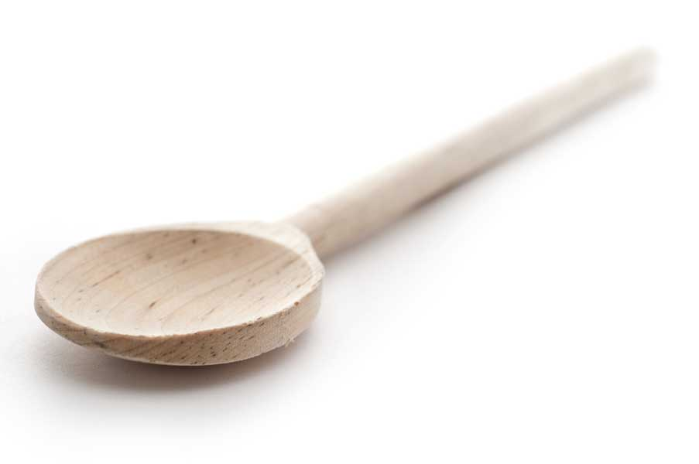
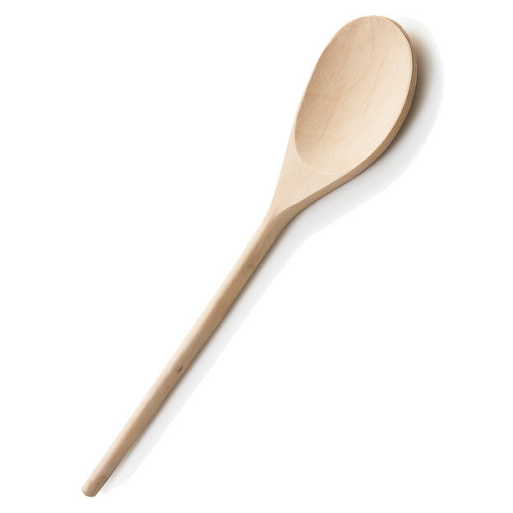
favs
frans

Marinated Grilled Flank Steak with Asian Flair

Ingredients

1 cup soy sauce
1/3 cup sugar
1/3 cup rice wine vinegar
1/4 cup chopped onion
1/2 cup peeled, chopped Asian pear or regular pear (D’Anjou, Bosc)
1 1/2 tbl. sesame oil
1 1/2 tbl. freshly grated orange zest
2 1/2 tbl. chopped fresh ginger root
8 cloves garlic
2 lbs. flank steak, cut into four 8-oz. pieces
Canola or vegetable oil
Green onions or scallions for garnish, optional

Directions

Place first 9 ingredients in a blender. Blend into a smooth sauce. Pour the sauce into a heavy-duty, resealable plastic bag. Add the steak and marinate for up to 24 hours in the refrigerator.

Remove steaks from marinade. (Discard marinade.) Preheat grill to medium-high. Brush grill rack with oil. Grill steaks 4 to 5 minutes a side or until desired doneness. Remove steaks to a platter. Cover with foil and let rest 5 minutes before serving.

www.fransfavs.com

