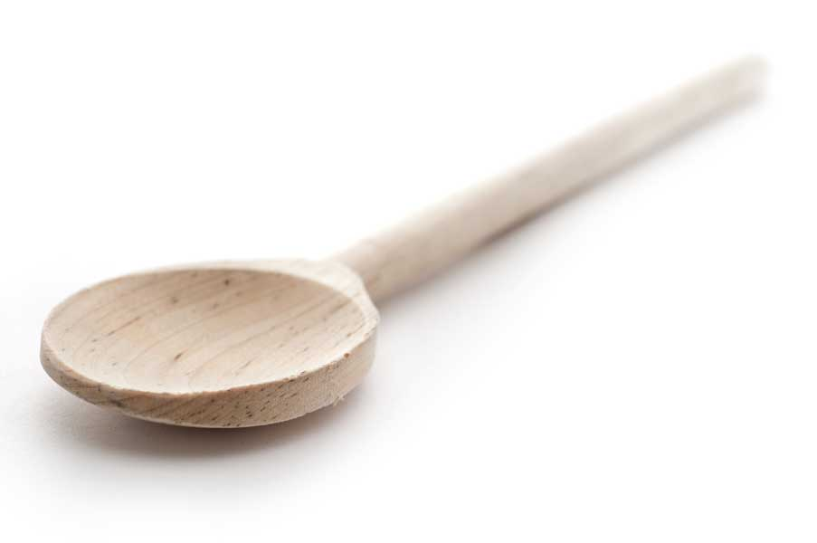

favs
frans

Mocha Smoothie

Makes 2 servings

Ingredients

12 oz. coffee, regular or decaf
1 cup almond milk (or milk of your choice)
2 scoops chocolate protein powder
2 to 3 tbl. sugar (I used 3 tbl., but I have a sweet tooth)
2 cups ice

Directions

Put all ingredients except the ice in a blender which has an ice-crushing feature. Process until ingredients are blended. Add ice and blend until smooth but still somewhat icy.

www.fransfavs.com

