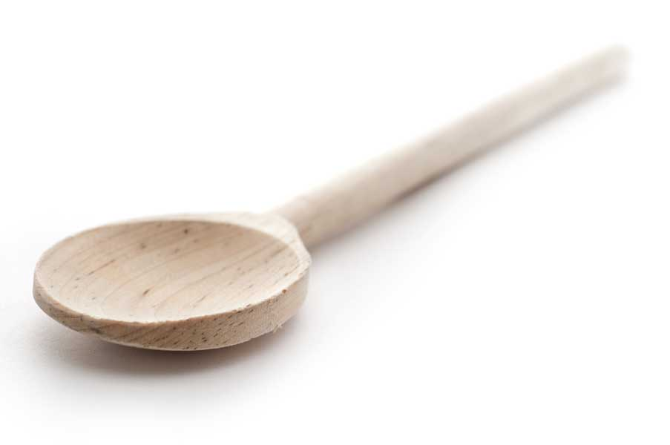
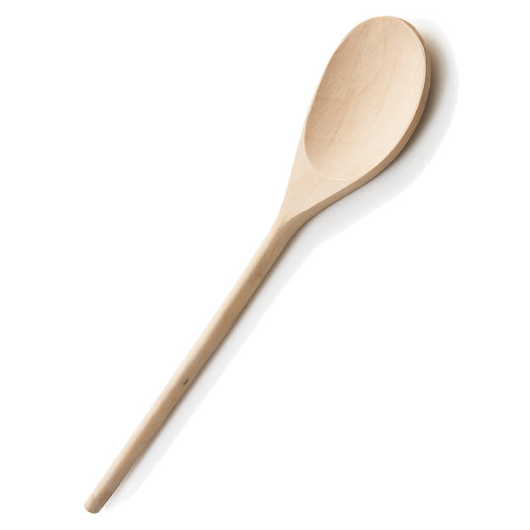
favs
frans

Peppermint Cream Meltaway Bars

Ingredients for Cookie Dough

2 cups unsalted butter, softened
1 cup confectioners' sugar
4 cups flour
4 tsp. cornstarch
3/4 tsp. sea salt

Ingredients for Cream Filling

12 oz. cream cheese, softened
1 egg yolk
3 tbl. confectioners' sugar
Giant pinch of sea salt
Handful (or two) of the Andes Peppermint Crunch chips in the filling
(plus you will use more of the peppermint crunch chips for topping the cream cheese
filling)
1/2 tsp. mint extract, optional if you prefer a strong mint flavor (I didn't use)

Ingredients for Topping

Icing (1 cup of confectioners' sugar, mixed with splash or two of heavy cream, and dash of mint extract)
Andes Peppermint Crunch chips

Directions for the Dough

Using a mixer, mix butter and confectioners' sugar until creamy with no lumps. Add in the flour, cornstarch and salt. You can use your hands to mix until just combined; no need to overwork the dough. It should be light and airy, not tough. The dough will be dry—that's OK; just place it on plastic wrap, mold into a large ball or disk and wrap tightly. Place in fridge for at least 4 hours or overnight.

When ready to bake, turn out the dough onto parchment paper; divide the dough into 2/3 and 1/3 portions. The 2/3 dough portion is the bottom layer and the 1/3 dough portion will be the crumble topping.

Turn the larger dough onto a greased 9 x 13 baking pan. Using your hands spread the dough out evenly into the pan. If dough is too cold, let it warm up a bit. While you’re waiting, make the filling.

Directions for the Filling

Mix the cream cheese, egg yolk, powdered sugar and handful (or two) of chips in a bowl.

Preheat oven to 350º F. Your dough should be nicely and evenly placed out into the baking pan, making sure to get all the corners. Add on the cream cheese filling. Do not spread the filling to the edges! Next take the peppermint crunch chips and add a layer on top of the filling. How much? Maybe a half cup or more; just use your judgment.

Then taking the remaining 1/3 of the dough, place medium size, flattened dough crumbles on the top. No need to push these down into the dough. Just crumble them on like you would a crumb cake. The flatter the crumb the better chance it has for crisping up.

Bake about 45 – 55 minutes. Look for golden brown edges and lightly golden brown crumbs on top.

While the bars are baking, make the icing by combining the powdered sugar with the dash of mint extract, and heavy cream.

When bars have cooled completely, drizzle the icing on top and then top with more of the peppermint crunch chips.

www.fransfavs.com

