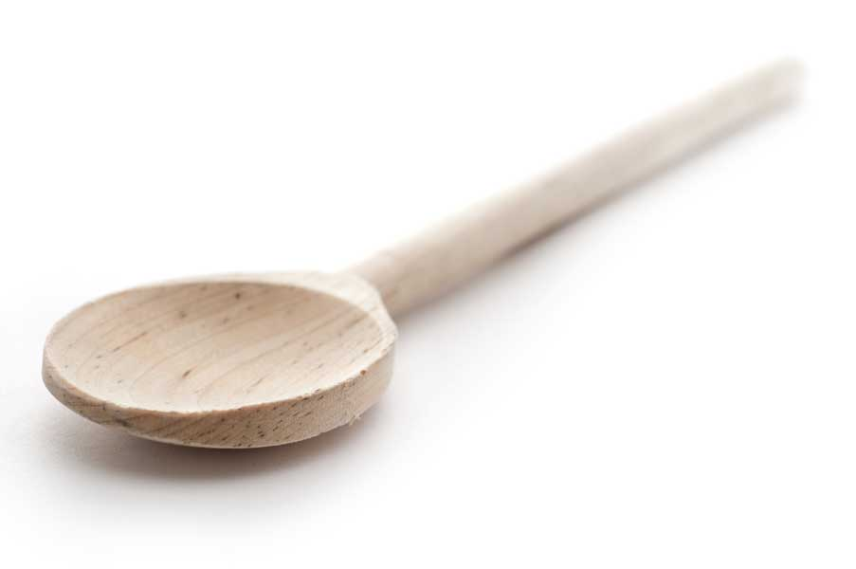
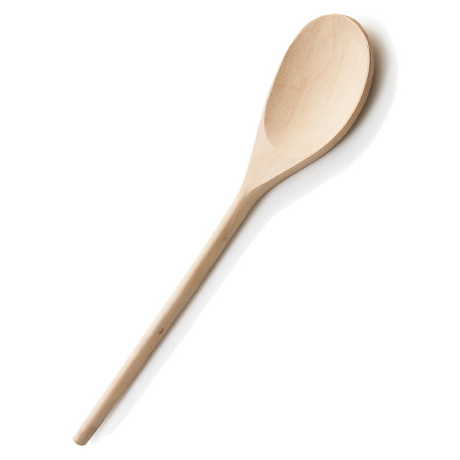
favs
frans

Cheesecake Lemon Bars

Ingredients for the Shortbread Layer

1 1/2 cups flour
1/2 cup confectioners' sugar
1/4 tsp salt
3/4 cup (12 tbl.) unsalted butter, cold and diced into small cubes

Ingredients for Lemon Layer

1 1/2 cups granulated sugar
1 tbl. flour
4 large eggs
1/2 cup lemon juice
1 1/2 tbl. lemon zest

Ingredients for Cheesecake Layer

2 (8 oz.) pkg. cream cheese, at room temperature
3/4 cup granulated sugar
2 large eggs
1 tsp vanilla extract
1/4 cup sour cream

Sour Cream Layer

1 cup (8 oz.) sour cream
4 tbl. confectioners' sugar

Directions for the Shortbread Layer

Preheat oven to 350º F. Butter a 13 by 9-inch baking dish, set aside.

In a mixing bowl whisk together flour, powdered sugar and salt. Using a pastry cutter or fork, cut butter into flour mixture until it resembles coarse meal. Pour mixture into prepared baking dish and spread and pat into an even layer. Bake in preheated oven until set, about 15 - 18 minutes. Set aside to cool slightly while preparing fillings.
Directions for the Lemon Layer

In a mixing bowl whisk together sugar, flour, eggs, lemon juice, and lemon zest until well blended. Set aside (don't pour into crust yet, you don't want it to soak into the shortbread layer while you're preparing cheesecake filling).

Directions for the Cheesecake Layer

In a mixing bowl, using an electric hand mixer set on low speed, cream together cream cheese and granulated sugar until smooth, about 30 seconds. Mix in eggs one at a time adding in vanilla with second egg. Mix in 1/4 cup sour cream. Tap bowl against countertop about 10 times to release any large air bubbles.

Pour lemon filling over crust then evenly pour cheesecake filling over lemon layer. Skim off any air bubbles. Gently spread cheesecake filling into an even layer. Bake in preheated oven until filling only jiggles slightly, about 29 to 33 minutes. Remove from oven and allow to cool at room temperature 45 minutes; then transfer to refrigerator and chill at least 2 hours.

Directions for the Sour Cream Layer

In a small mixing bowl whisk together sour cream and powdered sugar. Spread into an even layer over chilled bars. Cut into squares. Store in an airtight container in refrigerator.

www.fransfavs.com

