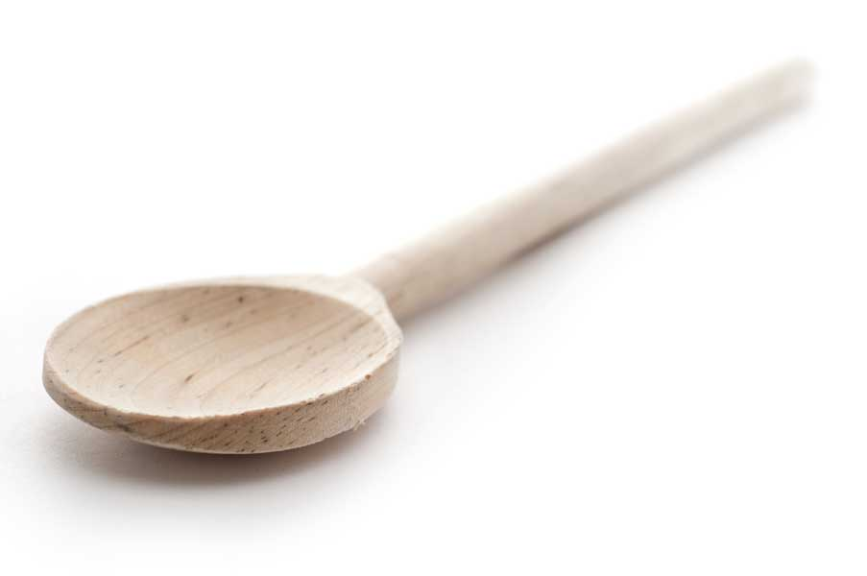
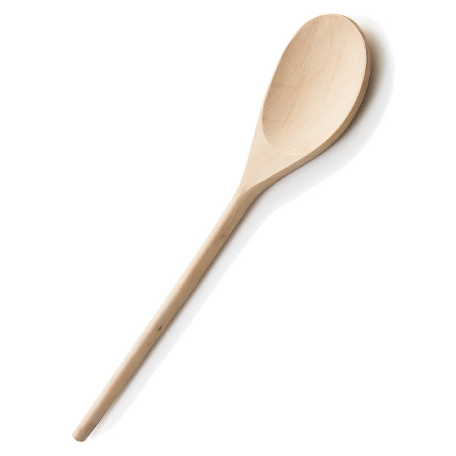
favs
frans

Anise Biscotti
Ingredients
5 cups flour
4 tsp. baking powder
1/2 tsp. baking soda
1/2 tsp. salt
1 cup (2 sticks) unsalted butter, room temperature
4 eggs
1 1/2 cups sugar
2 tbl. of anise extract
2 tbl. anise seed

Directions

Prepare two large cookie sheets by lining them with parchment paper. Set aside.

Whisk flour, baking powder, baking soda, salt, and anise seed together. Set aside.

In a large bowl with a mixer beat butter and sugar together until fluffy. Add eggs one at a time along with the anise extract. Add flour mixture and beat on low until blended. If the dough is at all sticky, chill it in the fridge for an hour or so. You can also chill it overnight. It is a very easy dough to handle and shouldn’t stick to your hands.

Divide cookie dough into 4 parts. Form each part into a log measuring around 2 1/2 inches by 9 or 10 inches long. Place logs on a parchment-lined baking sheet.

Bake in a preheated 350º F oven* for 20 to 25 minutes or until golden brown on the bottom. Remove from the oven and let them cool down on a rack. Carefully cut logs into 1/2-inch thick slices.

*Stagger your oven shelves so that they are in the upper and lower third of your oven. Bake cookies for 10 minutes and then swap the cookie sheets so that they finish on the opposite shelf from where they started.

Preheat oven to 300º F.

Stand each piece up on their bottom on cookie sheets so that both sides are exposed and bake for 15 minutes or until lightly golden. Once again, bake the two cookie sheets on staggered oven shelves and then reverse their position after half the baking time.

Makes around 75 biscotti depending on size.

www.fransfavs.com

