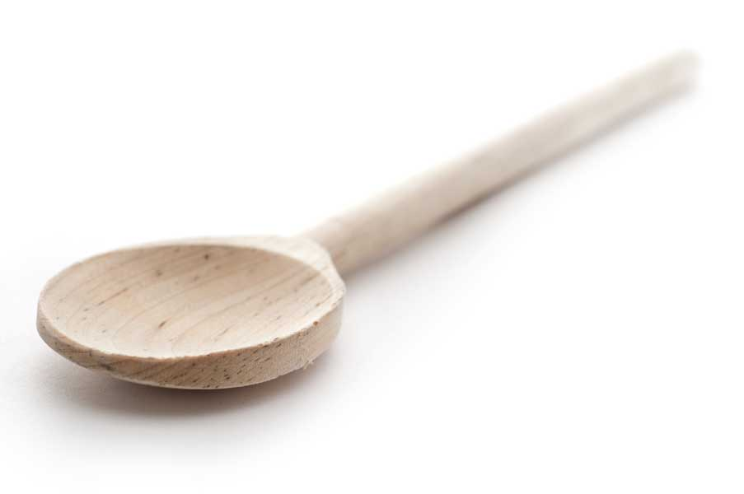
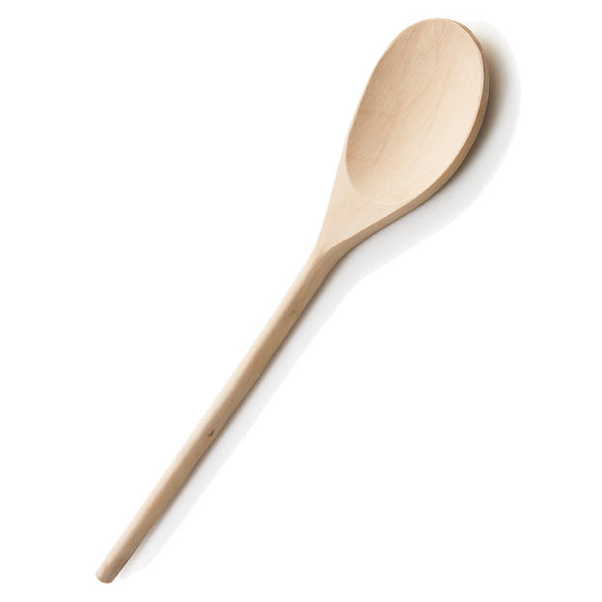
favs
frans

Chocolate Chip Muffins

Fran’s Notes

This recipe will make 14 regular-sized muffins or approximately 3 1/2 dozen mini muffins. This time around, I actually made 24 mini muffins and 6 regular size.

Ingredients

2 cups flour
1 cup sugar
3 tsp. baking powder
1/2 tsp. salt
1 cup milk
1 tsp. vanilla
1/2 cup vegetable oil
1 egg
1 cup mini chocolate chips

Directions

Prepare muffin tins—see my notes above to figure out how many you’ll need. Use paper cup liners or a baking spray to coat muffin wells. Set aside.

Whisk flour, sugar, baking powder, and salt in a large bowl. In a separate bowl, beat egg; then add milk, oil, and vanilla. Beat by hand to incorporate.

Add liquid ingredients to dry ingredients. Stir to blend together, but do not overmix—stir just enough to incorporate ingredients. Gently stir in chocolate chips.

Bake at 375º F for approximately 10 minutes for mini muffins and 15 minutes for standard-sized muffins. Check for doneness with a toothpick.

www.fransfavs.com

