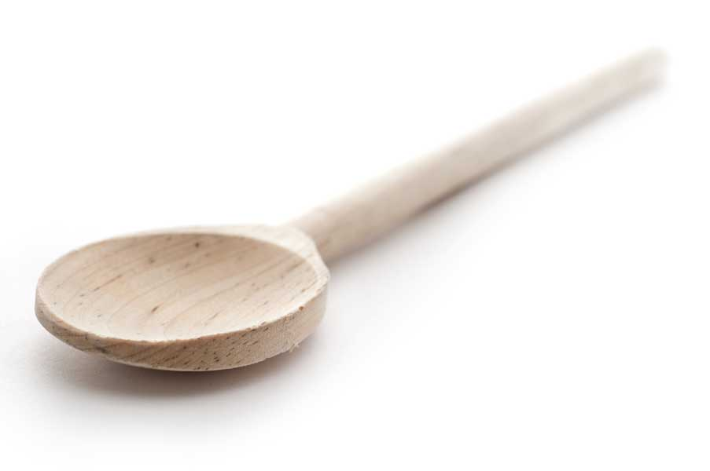
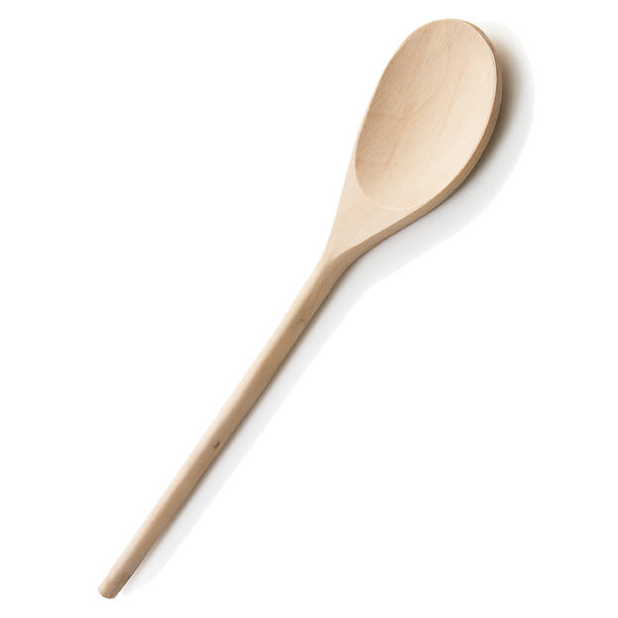
favs
frans

Green Chile Chicken Tacos with Mexican Street Corn

Makes 2 servings

Ingredients

1 to 2 tbl. olive oil
Kosher salt & pepper to taste (For a guide, I specified how much salt I used in directions. For pepper, I gave my usual 2 or 3 twists with my pepper mill.)
2 boneless skinless chicken breasts
1 lime, divided
1 clove garlic, minced
6 oz. tomatillos, peeled and rinsed
2 to 4 tbl. cilantro, divided
1 poblano chile
2 tbl. diced green chiles
6 corn tortillas
2 cups corn
2 tsp. plus 1/4 cup mayonnaise, divided
2 oz. queso fresco, divided
1/2 tsp. chipotle paste

Directions

Season chicken with 1/2 teaspoon of salt and pepper to taste. Heat oil in medium pan over medium-high heat. When oil is shimmering, add chicken and sear until cooked through and no longer pink, approximately 4 minutes per side depending on thickness of chicken. Transfer chicken to a plate or cutting board and set aside to rest, about 5 minutes. Wipe pan clean and reserve for cooking salsa.

While chicken cooks, halve lime; cut one half into wedges for serving. Mince garlic. Remove and discard husks from tomatillos, rinse well, and cut into 1/2-inch pieces. Rinse cilantro and roughly chop leaves, discarding stems. Rinse poblano, halve lengthwise, and using a knife tip, discard seeds and steam; cut into 1/2-inch pieces. Once rested, roughly chop chicken.

Return pan from chicken to medium-high heat and add 1 tablespoon olive oil. When oil is shimmering, add garlic, tomatillos, poblano, and half of cilantro. Cook until tomatillos are soft and jammy, 6 to 8 minutes. Reduce heat to medium and add green chiles, chopped chicken, 3 tablespoons of water, 1/4 teaspoon salt and pepper to taste. Simmer until liquid is fully evaporated, 2 to 3 minutes. Remove from heat and cover to keep warm.

Stack tortillas, wrap in foil, and place in a 425º F preheated oven to warm through, about 5 minutes. Meanwhile heat 1/2 tablespoon olive oil in a large pan over medium-high heat. When oil is shimmering, add corn and sauté, stirring, until warmed through and beginning to brown, about 5 minutes. Remove pan from heat. Stir in 2 teaspoons mayonnaise, half of queso fresco, juice of 1/2 lime, 1/4 teaspoon salt, and pepper as desired.

Make Chipotle Crema: Stir chipotle paste and 1/8 teaspoon salt in 1/4 cup of mayonnaise. Combine to make crema and set aside until ready to serve.

Divide warmed tortillas between serving plates and fill with green chile chicken, remaining cilantro, and remaining queso fresco. Drizzle chipotle crema over. It’s a bit spicy, so start with a little and adjust per your taste. Serve with Mexican street corn and lime wedges for squeezing over.

Fran’s Notes

I made the recipe exactly as is, and it was delicious. Since I am, however, a notorious tweaker of recipes and since I adore cumin, I think next time I’ll add some.

www.fransfavs.com

