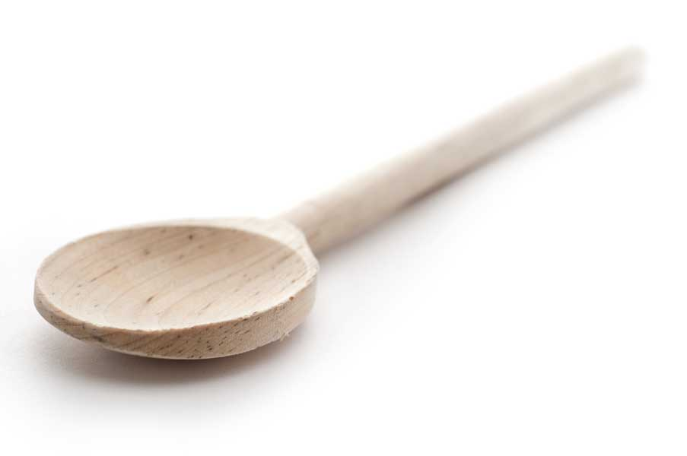
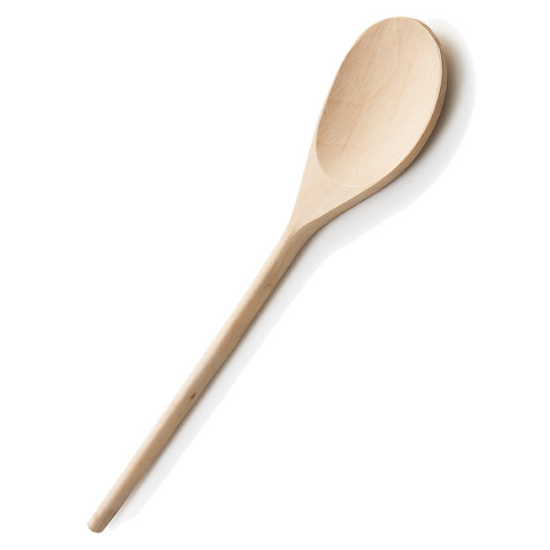
favs
frans

Momofuku Milk Bar Rosemary Nuts

Ingredients

1 pound raw unsalted nuts of your choice (I prefer pecans to catch the seasonings—but choose your favorite or a combination of your favorite nuts)
2 tbl. unsalted butter, melted
1/3 cup packed light brown sugar
3 tbl. chopped fresh rosemary
2 tsp. kosher salt

Directions

Heat the oven to 350° F.

Spread the nuts evenly on a baking sheet and roast for 8 to 10 minutes or until fragrant and beginning to brown. Transfer the nuts to a large bowl (set the baking sheet aside).

Mix the butter with the sugar, rosemary, and salt, pour it over the warm nuts, and toss with a wooden spoon. Spread the nuts back on the baking sheet and let them cool on the counter for 30 minutes, or until all elements have solidified and cooled. Serve at room temperature. (They’re not as good if you try to eat them while they’re still warm.)

www.fransfavs.com

