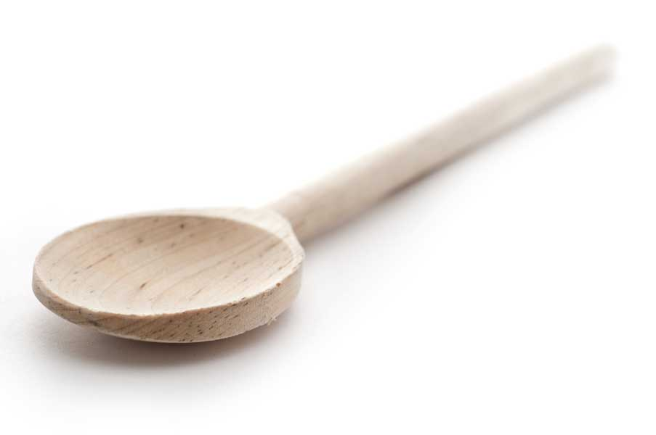
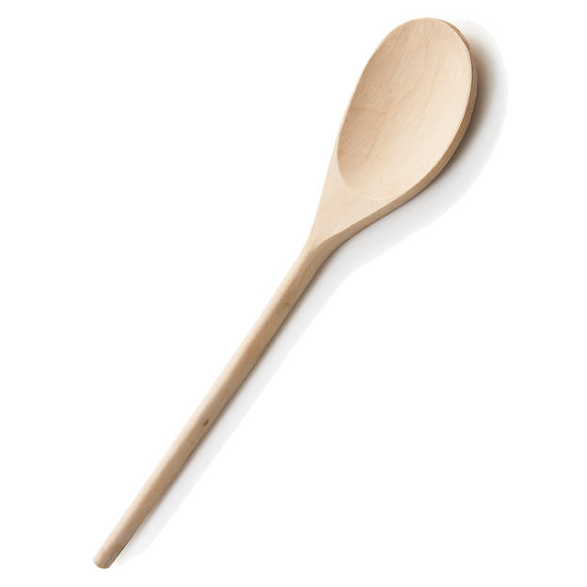
favs
frans

Dukan Diet Muffins

Makes 12 muffins, less than 100 calories each

Ingredients for Carrot Muffins

3/4 oat bran (may need a bit more oat bran depending on consistency of batter)
6 tbl. stevia
1 tsp. baking powder
1/2 tsp. baking soda
1/8 tsp. salt
1 tbl. plus 1/4 tsp. cinnamon
1/4 tsp. nutmeg
4 large eggs, beaten
3 to 4 tbl. maple syrup (I like to use a scant 1/4 cup)
3/4 cup yogurt
1 1/2 tsp. vanilla
1 cup carrots, finely minced
1/2 cup chopped pecans or walnuts, optional

Directions

Use a baking spray to coat the cups of your muffin tin. Alternatively, you can use paper liners, but I’ve found that too much of the muffin sticks to the paper. Set aside while you prepare the muffins.

In a large bowl, whisk together the dry ingredients: oat bran, stevia, baking powder, baking soda, salt, cinnamon and nutmeg. Stir in the beaten eggs until incorporated; then mix in the maple syrup, yogurt, vanilla, and carrots. Stir in chopped nuts if you are using them. Be careful not to overmix or the muffins will not turn out as tender as they should. The batter will be somewhat loose. If it appears runny, add another tablespoon of the oat bran. I’ve had to do that on occasion as some eggs add more liquid than others.

Divide the batter evenly among the 12 cups.

Bake in a preheated 350º F oven for approximately 16 to 18 minutes. Mine are always perfect after 17 minutes, but you may need a minute more or less depending on your oven. Serve warm. Refrigerate remaining muffins and refresh by warming them up in the microwave at 50% power for 15 to 20 seconds.

www.fransfavs.com

