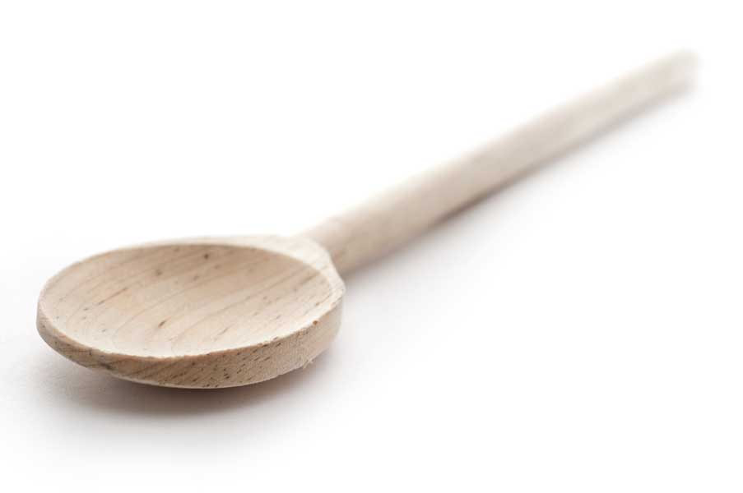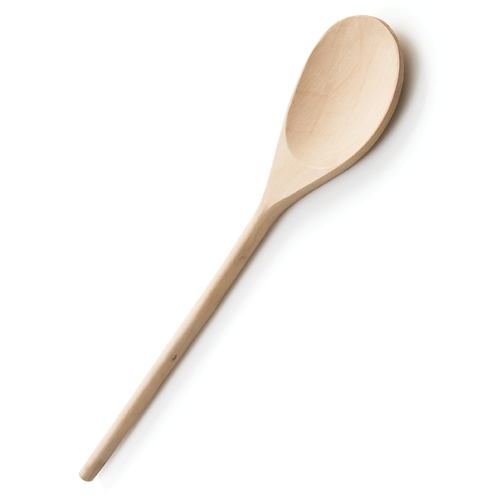

Starbucks Copycat Honey Citrus Mint Tea aka Medicine Ball

Ingredients

- 1/2 cup water
- 1 1/2 cups lemonade (I used Simply Lemonade)
- 1 Tazo Zen tea bag (or mint green tea of your choice)
- 1 Bigelow Perfect Peach herbal tea bag (or peach herbal tea of your choice)
- 1 to 2 tsp. honey (I have a sweet tooth, so I use 2 tsp.)

Directions

Add water and lemonade to a small saucepan and bring to a boil over medium-high heat.

Remove saucepan from heat and add both tea bags. Let steep for 5 minutes before removing tea bags and discarding.

Stir honey into tea.

Pour into a mug and enjoy.

www.fransfavs.com

